A Novel Approach to AI integration with an Existing Stochastic Modelling Formulation.
Richard “RJ” Morrison
Department of Industrial and Systems Engineering
University of Missouri, Columbia, MO 65211

Abstract

This interim explores the progress towards an integration of artificial intelligence (AI) with stochastic modeling to develop a tool that may enable non-technical users to solve complex operational problems. Specifically, the research investigates whether a natural language interface can be effectively paired with stochastic optimization frameworks to generate feasible workforce scheduling solutions. The proposed tool utilizes the Pyomo library and the CBC solver to reconstruct the Stochastic Multi-Activity Tour Scheduling Problem (SMASTP), a workforce scheduling model that incorporates uncertainty in demand. By enabling users to interact with an AI-powered stochastic specialist, the system aims to bridge the expertise gap in stochastic optimization, allowing organizations to formulate and solve scheduling problems without requiring deep technical knowledge. At this stage, the research methodology involves implementing the SMASTP model in Pyomo, comparing its results to the original formulation and assessing accuracy. current results indicate that while the model can generate valid scheduling solutions, computation time and VSS metrics indicate issues with the current formulation. Future work will focus on refining the solver's performance, enhancing the AI interface, and developing a user-friendly system for operational decision-making. This study contributes to the ongoing evolution of AI-driven decision-support tools in industrial and systems engineering.

Keywords: Stochastic modeling, AI integration, workforce scheduling, Pyomo, SMASTP, optimization

Introduction (1 page)

Decision-making under uncertainty is a fundamental challenge across industries, from workforce scheduling to supply chain optimization. Over the past 150 years, stochastic optimization has emerged as a powerful mathematical framework to address such uncertainties, providing structured approaches for modeling and solving real-world operational problems [7]. These methods have been applied to diverse operational contexts, including staff scheduling, production planning, and risk management, offering businesses more robust decision-making capabilities [9]. However, despite their effectiveness, stochastic optimization techniques remain largely inaccessible to organizations without specialized expertise. Businesses without in-house industrial engineers often rely on proprietary software solutions or external consultants, both of which impose significant financial and operational constraints.

Recent advancements in artificial intelligence (AI), particularly in natural language processing (NLP), present an opportunity to bridge this accessibility gap. The release of OpenAI’s ChatGPT-3.5 in 2022 demonstrated the potential of foundational AI models to process and generate human-like responses to complex queries [10]. By 2025, multiple companies have developed large-scale, general-purpose AI models, capable of tokenizing and analyzing text, images, and structured data. However, these models often struggle with specialized domains where training data is sparse, such as stochastic optimization [1]. Furthermore, existing AI-powered decision-support systems tend to be algorithm-driven rather than human-driven, meaning they function as autonomous analytics layers rather than interactive problem-solving tools [10]. This limitation raises an important question: Can the NLP aspect of AI be leveraged to enhance the usability of stochastic optimization frameworks, enabling non-experts to formulate and solve complex operational problems through an intuitive interface?

This research proposes an AI-powered decision-support tool that integrates natural language processing with stochastic modeling techniques. Specifically, the study focuses on the Stochastic Multi-Activity Tour Scheduling Problem (SMASTP), a workforce scheduling model that accounts for uncertainty in employee assignments [11]. The objective is to develop an AI-assisted system where users interact with a digital stochastic specialist, guiding them through problem formulation and solution generation. The core technical approach involves reconstructing the SMASTP model in Pyomo, utilizing the CBC solver, and benchmarking its performance against existing methodologies [2, 4].

By integrating AI-driven natural language interfaces with stochastic programming, this research aims to lower the technical barrier to optimization, making interacting with advanced decision models accessible to a broader range of users. The effectiveness of the proposed system will be evaluated based on usability, computational efficiency, and solution accuracy, with comparative analysis against traditional stochastic solvers [5]. Ultimately, this work seeks to establish a framework where businesses and decision-makers can engage with complex optimization problems through intuitive, AI-driven interactions, making stochastic modeling more practical for real-world applications.

Literature Review

Existing AI Applications in Models
Currently, AI is already implemented in operational contexts. It’s a key tool in powering backends of powerful analytical management systems. Use cases range for predictive maintenance or an optimized warehouse management system. The application of AI onto operations is also nothing new and predates the large language models that power ChatGPT. [10] For this purpose of this paper, two features from these existing implementations standout. First, current AI systems layer themselves on top of existing data structures, where big data systems are used as an input for a powerful prediction mechanism. Second, current AI implementations can be observed to be ‘algorithm driven’ as opposed to ‘human driven’. Human driven would imply that the analysis of an implementation would answer an immediate management prompted question. A system being algorithm driven is defined by a fixed-robust framework that exists on top at least one facet of an operation, the human interaction is the decision to implement the framework and occasionally use an observation calculated by the framework.

Existing Human Driven Stochastic Tools
The best layer to start understanding available solutions is to start with the software-based optimization frameworks. These are programs that use stochastic algorithms there are two solutions that standout, number one is GAMS and number two is Pyomo. Both programs are built to take computer code with specific syntax to inject it as context for a separate solver. Thus, the next layer are the solvers that framework tools inject into. The most popular of these solvers is potentially CPLEX, but for open-source solutions two powerful solvers are CBC and IPOPT. Further, there are the models that already exist that can turn context into an outline of for deterministic Pyomo or GAMS code [1].

Feature | CBC [4] | IPOPT [5] | CPLEX [6]
Type of Solver | Mixed-Integer Linear Programming (MILP) | Nonlinear Programming (NLP) | Linear, Mixed-Integer, and Quadratic Programming (LP, MILP, QP, MIQP, etc.)
Problem Types | Linear problems with integer variables | Continuous, nonlinear, and smooth optimization problems | Linear, quadratic, and integer problems
Open Source | Yes | Yes | No (commercial, with free academic license)
Algorithm | Branch-and-Cut for MILP | Interior-Point Method for NLP | Simplex, Barrier, and Branch-and-Bound/Cut for MILP and QP
Performance | Good for small to medium MILPs | Excellent for large-scale NLP | Industry-standard, highly optimized for large-scale LP, MILP, and QP
Parallelization | Limited | No | Fully parallelized and highly scalable
Ease of Use | Easier for linear problems | Requires smooth, differentiable functions | Highly flexible with extensive modeling capabilities
Typical Applications | Scheduling, routing, resource allocation | Nonlinear control, optimal power flow, nonlinear portfolio optimization | Industry-scale problems in logistics, finance, energy, etc.
Table 1: An outline of three different stochastic solvers.

The Stochastic Multi-Activity Tour Scheduling Problem (SMATSP)
This paper is exploring workforce scheduling challenges in service organizations, with scenarios in which employees can perform several different tasks within a single shift, and these shifts must be repeated across multiple days, possibly under uncertain demand. In a 2017 paper by Restrepo, Gendron, and Rousseau. they explore relevant deterministic problems, and then a stochastic model that exactly fits the description of this new research paper. There is the Multi-Activity Shift Scheduling Problem (MASSP) which focuses on building daily shifts with multiple activities, adhering to constraints such as break placement, minimum and maximum shift length, and activity-switching rules. There is also the Multi-Activity Tour Scheduling Problem (MATSP) which then expands on MASSP by extending the planning horizon to multiple days, commonly a week, introducing additional regulations for day-off allocation, weekly total hours, and extended rest periods, thereby generating full “tours” for each employee. Finally, the Stochastic Multi-Activity Shift and Tour Scheduling Problem (SMASTP) incorporates randomness by using a two-stage stochastic model. In this approach, employee tours are decided in the first stage (without complete information on daily demand), and second-stage decisions refine task allocation, such as when lunch breaks are taken, after real demand is realized—allowing for explicit under- or over-staffing costs. Taken together, these problems illustrate a progression from single-day, deterministic scheduling (MASSP), to multi-day, deterministic solutions (MATSP), and ultimately multi-day, stochastic models (SMASTP), each step adding new layers of complexity to achieve more robust and realistic workforce solutions. [11]

Literature Overview
The landscape of operational AI solutions demonstrates a clear opportunity to introduce human-driven deep-analytical tools that use robust decision frameworks which formerly were purely algorithm driven. Existing AI applications, whether in predictive maintenance or warehouse optimization, primarily rely on robust data structures and automated decision layers, where human intervention is limited to what could be called strategic oversight rather than direct intervention. Similarly, programmed optimization tools, such as Pyomo and GAMS, provide structured frameworks for integrating powerful solvers like CBC and IPOPT, enabling engineers to model complex operational problems with complex but formulaic math. Finally, within workforce scheduling, which would be in the scope of this project, the Stochastic Multi-Activity Tour Scheduling Problem (SMATSP) represents a good starting point to start integrating stochastic modeling with existing AI language models.

Mathematical Modeling (3 pages)

3.1. Problem Description (1 page)

Problem Statement
The SMASTP problem described and solved by Restrepo is a broadly applicable model for solving employee schedules that has evolved from existing deterministic frameworks. The new problem is to re-formulate the SMASTP problem in Pyomo using an open-sourced solver, then re-working that Pyomo solution to accept natural language interactions.

Model Introduction
The basis of this paper’s model is found from the Restrepo, B. Gendron, and L.-M. Rousseau’s, "A two-stage stochastic programming approach for multi-activity tour scheduling”. It applies the L-Shaped Multi Cut algorithm to a two-stage stochastic problem. The objective of the model is to minimize the cost of its recourse, which itself represents the cost of assigning workers to activities in addition to the cost of overcovering or undercovering demand. Construction of activities is very flexible with Restrepo et al themselves utilizing an approach from another paper where activities get put together in a parent-child grid to mathematically represent all possible combinations of work. The SMASTP in question is multi-day, it is “Anonymous”, meaning that workers are assumed to have identical skills and costs, it is “Discontinuous”, meaning shifts are not able to cross from one day into another, and it is “Flexible”, meaning that shifts and activities are constrained but not fixed. The uncertain variable is the demand of any-activity at any point in time.

Key Terms
The model uses a grammar-based approach to systematically generate feasible work shifts by defining parent child relationships that dictate how schedules can be structured. The grammar and relationships come together to form a Directed Acyclic Graph (DAG) representing all possible valid shifts. The Dag for each day is represented by $Γ_{d.}$The model uses the DAG to construct different “shift shells”, which are basic scheduling units that specify when a shift starts, how long it lasts, and the required working hours. From these shift shells, the model generates tours, which represent complete, multi-day work schedules for employees. A tour is a sequence of shifts assigned to a worker, ensuring that constraints such as rest periods, total weekly hours, and workload balance are met. The model makes diverse styles of tours to try and optimize schedules, with the idea to get close to meeting operational demands while adhering to labor regulations and worker preferences. This approach, again coined from Restrepo, Gendron, and Rousseau, is meant to ensure that the optimization model has a well-defined and flexible set of scheduling options to evaluate when finding an optimal workforce assignment.

Grammar and DAG Overview
The grammar-based approach defines the relationship between rules that can generate valid shift schedules by specifying how work and break periods can be arranged. From the original paper, the system consists of terminal symbols represented by $\sum_{d}{ }$ non-terminal symbols with $N_{d}$, daily production rules $P_{d}$, and a start symbol $S$, that are located by type of activity “j”, length “n”, and start time “i”. In this case, the terminals represent things like work blocks, breaks, and shift start times, while the non-terminals define broader scheduling concepts, such as the components within the shift structure. The production rules determine how shifts can be formed by specifying allowable transitions between work and break periods. For example, an 8-hour shift might be constructed using a sequence of work periods interspersed with short breaks and a mandatory lunch break. The model described here has different activities spanning different “i” 15-minute allocation of time, for “n” amounts of i. The lowercase Greek letter π is used to express individual terminal or non-terminal symbols whereas the capital ∏ is used to demonstrate feasible production sets.

Figure 1: A sequence of values that would represent a feasible shift for a worker with one work activity type, two break types.

The grammar ensures that only valid shift sequences are generated, avoiding infeasible or non-compliant schedules. To efficiently apply these rules, the model constructs a DAG, where each path through the graph represents a possible valid shift with established node relationships. The model builder then extracts structured shift shells from this representation, which serve as the foundation for constructing tours / full work schedules. By using a grammar-driven approach, this model provides a systematic and constraint-compliant way to generate shift structures that align with operational and labor requirements. That systemic characterization means we can apply math to describe the relationships!

Tour Generation Overview
The tour generation process relies on several key assumptions to ensure feasible and practical workforce scheduling. Tours are constructed by combining predefined shift shells, which are generated using the grammar-based DAG to maintain valid shift structures. Each tour must adhere to weekly working hour limits (e.g., 35-40 hours) and enforce a minimum rest period (e.g., 12 hours) between consecutive shifts. To promote diversity and flexibility, a diversity factor prevents repetitive scheduling patterns, and demand fluctuations are accounted for using stochastic scenario-based adjustments. Tours are designed to maximize coverage of workforce demand while balancing worker utilization and operational constraints. Additionally, schedules are structured to span multiple days, ensuring compliance with both legal labor requirements and business needs. These assumptions collectively guide the tour generation model, ensuring that schedules remain efficient, legally compliant, and adaptable to dynamic workforce demands.

3.2. Mathematical Model (2 pages)
Sets and Indices
$D$ : Set of days in the planning horizon.
$I_{d}$ : Set of time periods in day $d$.
$J$ : Set of work activities.
$E$ : Set of employees.
$T$ : Set of feasible weekly tours.
$S_{d}$ : Set of possible shift structures (shift shells) on day $d$.
$Ω_{d}$ : Set of demand scenarios for day $d$.
$p_{d}^{\left(w\right)}$ : Probability of scenario $w∈Ω_{d}$ on day $d$.

Parameters
$c_{dij}$ : Cost of assigning one employee to activity $j$ at time $i$ on day $d$.
$c_{dij}^{+}$ : Cost of overcovering one employee for activity $j$ at time $i$ on day $d$.
$c_{dij}^{-}$ : Cost of undercovering one employee for activity $j$ at time $i$ on day $d$.
$ξ_{dij}^{\left(w\right)}$ : Stochastic demand for activity $j$, at time $i$, on day $d$, in scenario $w$.
${ δ}_{dt}^{π,k}$ : Binary parameter, 1 if weekly tour $t$ includes shift shell $\left(π,k\right)$ on day $d$, 0 otherwise.

First Stage Decision Variables
$x^{t}$: integer variable that represents the number of employees assigned to tour t
$v_{d1n}^{Πk}$: variable that represents the number of employees assigned to the kth
child of the root node (shift shell) of length n, on day d.

First Stage Objective Function
The objective function of the primary problem is to minimize the total cost of the recourse summed across each day, across each possible scenario. This structure is how the Multi Cut scenario is embedded into the solution, with $θ$ described in the constraints.
$$\begin{aligned}f\left(B_{T}\right)=\min{\sum_{d∈D}{\sum_{w∈Ω_{d}}{θ_{d}^{\left(w\right)}}}}\#\left(1\right)\end{aligned}$$

First Stage Constraints
Equation 2 represents that the number of employees assigned to tasks is exactly equal to the number of employees assigned to valid tours. This is for all $A_{d1n}^{Π,k}∈ch\left(O_{d1n}^{S}\right)$, which represent the top layer of shifts for each day. This hard constraint confirms that employees are not being assigned to tours that are do not exist. Equation 4 makes sure that there are no more employees assigned to tours than employees available. Equation 3 represents that theta must be greater to or equal to the weighted cost of each of our scenarios.

$$\begin{aligned}v_{d1n}^{Π,k}=\sum_{t∈T}{δ_{dt}^{Π,k}x_{t}}, ∀d∈D,A_{d1n}^{Π,k}∈ch\left(O_{d1n}^{S}\right),\#\left(2\right)\end{aligned}$$

$$\begin{aligned}θ_{d}^{\left(w\right)}≥p_{d}^{\left(w\right)}Q\left(v_{d},ξ_{d}\left(w\right)\right), ∀d∈D,w∈Ω_{d},\#\left(3\right)\end{aligned}$$

$$\begin{aligned}\sum_{t∈T}{x_{t}}=\left|E\right|,\#\left(4\right)\end{aligned}$$

$$\begin{aligned}x_{t}≥0\text{ and integer}, ∀t∈T,\#\left(5\right)\end{aligned}$$

$$\begin{aligned}v_{d1n}^{Π,k}≥0, ∀d∈D,A_{d1n}^{Π,k}∈ch\left(O_{d1n}^{S}\right)\#\left(6\right)\end{aligned}$$

Second Stage Decision Variables
$y_{dij}^{\left(w\right)}$: Number of employees assigned to activity $j$ at time $i$ on day $d$ in scenario $w$.
$v_{dil}^{π,k,\left(w\right)}$: Number of employees assigned to a lower-level shift component in the daily shift DAG.
$s_{dij}^{+\left(w\right)}$, $s_{dij}^{-\left(w\right)}$ : Slack variables for overcovering and undercovering demand.

Second Stage Objective Function
The second stage objective function (equation 7) represents the minimization of the recourse function. Where the total cost of assigning activities is put in addition to the cost of over/under covering demand, across all activities, across days.
Qv,ξw=mind∈D​i∈Id​j∈J​cdijydijw+d∈D​i∈Id​j∈J​cdij+sdij+w+cdij-sdij-w#7
Second Stage Constraints
The constraint described in equation 8 defines how we can use slack variables in addition to our assigned worked to establish the relationship between demand and fulfillment. Equations 9, 10, and 11 are required to make sure that there the number of workers assigned to shifts is equal to the total amount of workers (11), and the number of workers assigned to activities is equal to the available workers that around to perform an activity (9 and 10). Equations 12 and 13 confirm non-negativity.

$$\begin{aligned}y_{dij}^{\left(w\right)}-s_{dij}^{+\left(w\right)}+s_{dij}^{-\left(w\right)}=ξ_{dij}^{\left(w\right)}, ∀d∈D,i∈I_{d},j∈J,\#\left(8\right)\end{aligned}$$

$$\begin{aligned}\sum_{A_{dil}^{Π,k}∈ch\left(O_{dil}^{π}\right)}{v_{dil}^{Π,k,\left(w\right)}}=\sum_{A_{d1n}^{Π,k}∈par\left(O_{dil}^{π}\right)}{v_{d1n}^{Π,k,\left(w\right)}},\#\end{aligned}$$

$$\begin{aligned}∀d∈D,O_{dil}^{π}∈ch\left(A_{d1n}^{Π,k}\right)∖L_{d},\#\left(9\right)\end{aligned}$$

$$\begin{aligned}\sum_{A_{dil}^{Π,t}∈ch\left(O_{dil}^{π}\right)}{v_{dil}^{Π,k,\left(w\right)}}=\sum_{A_{dil}^{Π,k}∈par\left(O_{dil}^{π}\right)}{v_{dil}^{Π,k,\left(w\right)}},\#\end{aligned}$$

$$\begin{aligned}∀d∈D,O_{dil}^{π}∈O_{d}∖\{O_{d1n}^{S}∪L_{d}∪ch\left(A_{d1n}^{Π,k}\right)\},\#\left(10\right)\end{aligned}$$

$$y_{dij}^{\left(w\right)}=\sum_{A_{d1l}^{Π,k}∈par\left(O_{d1l}^{j}\right)}{v_{d1l}^{Π,1,\left(w\right)}}, ∀d∈D,i∈I_{d},j∈J,$$

$$\begin{aligned}v_{dil}^{Π,k,\left(w\right)}≥0, ∀d∈D,A_{dil}^{Π,k}∈A_{d}∖ch\left(O_{d1n}^{S}\right),\#\left(11\right)\end{aligned}$$

$$\begin{aligned}s_{dij}^{+\left(w\right)},s_{dij}^{-\left(w\right)}≥0, ∀d∈D,i∈I_{d},j∈J,\#\left(12\right)\end{aligned}$$

$$\begin{aligned}y_{dij}^{\left(w\right)}≥0\text{ and integer}, ∀d∈D,i∈I_{d},j∈J.\#\left(13\right)\end{aligned}$$

Experiment and Results (2 page)

Interim Experiment Status and Objective
To progress to the next stage of the project the developed Pyomo-CBC model must be measured and verified against something. Core limitations expected at this stage is that the solver is still under development and requires further tweaking to its codebase. The CBC model was picked because within Pyomo it’s able to implement the L-shaped multi-cut method.

Assigning Expected Demand
Using the grammar approach for modelling allows for very modular demand assignment. The primary activity of an employee is the range of 3 to 8, representing that the primary work for any activity could be 3 workers to 8 workers. This represents the mean requirement of the activity, but then factors related to the day of the week, and the time of day are layered on.

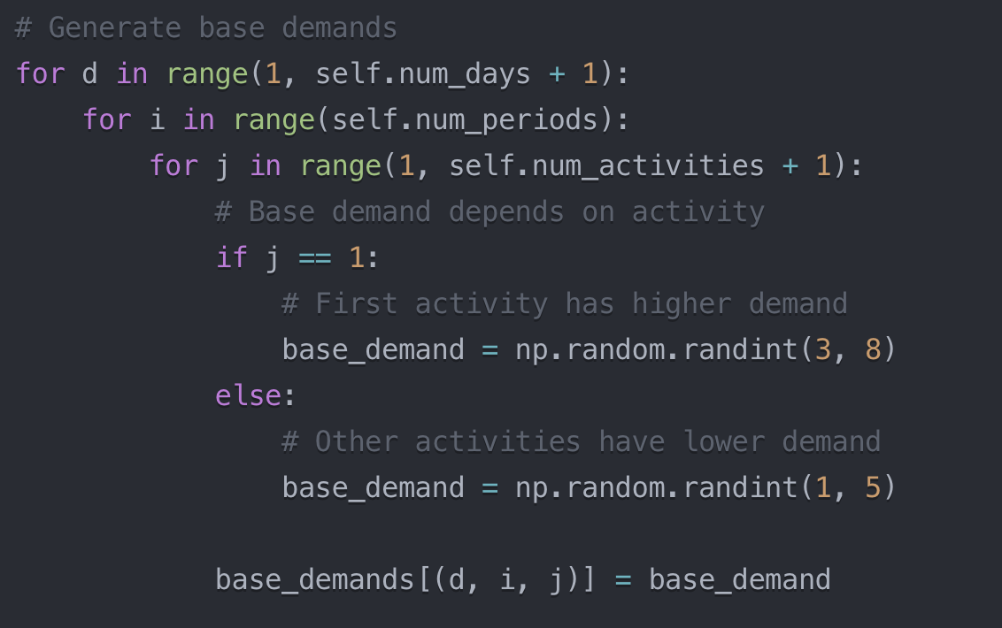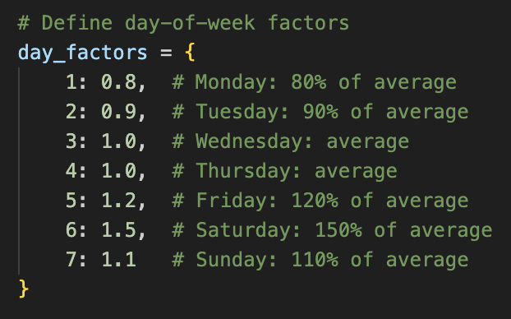
Figure 2 (Left): The function assigning demand to each activity
Figure 3(Right): Pretend weighting of the business demand.

Experimental DAG
The Exact specifications of Restrepo et al experiment the work requirements are described below. For the purpose of this stage of this experiment the tour construction and activity breakdown is meant to resemble that of the reference paper.

Tour generation
- The planning horizon is seven days, where each day is divided into 96 time periods of 15 minutes.
- Shifts are not allowed to span from one day to another (discontinuous problem).
- The tour working length should fall between 35 and 40 hours per week.
- The number of working days in the tour should fall between five and six.
- There must be a minimum rest time of twelve hours between consecutive shifts.
Daily shift generation
- Shifts can start at any time during any day, allowing enough time to complete their duration in day d.
- Three types of shifts are considered:
  - 8-hour shifts with 1-hour lunch break in the middle and two 15-minute breaks.
  - 6-hour shifts with one 15-minute break and no lunch.
  - 4-hour shifts with one 15-minute break and no lunch.
- If performed, the duration of a work activity is at least two hours and at most five hours.
- A break (or lunch) is necessary between two different work activities.
- Work activities must be inserted between breaks, lunch, and rest stretches.
- A fixed number of employees ∣E∣is given, therefore undercovering and overcovering of demand is allowed.
Experimental Parameters
$c_{dij}$ : 15
$c_{dij}^{+}$ : 20
$c_{dij}^{-}$ : $c_{dij}$ * 4 = 60

DAG Construction
$$G=(Σ=(aj​∀j∈J,b,l,r),$$
$$N=(S,F,Q,N,W,Aj ∀j∈J,B,L,R),P,S),$$
$$S→RFR∣FR∣RF∣RQR∣QR∣RQ∣RNR∣NR∣RN,$$
$$B→b,$$
$$L→llll,$$
$$F→\left[38,38\right]NLN,Q→\left[25,25\right]WBW,$$
$$N→\left[17,17\right]WBW,R→Rr∣r,$$
$$W→\left[8,20\right]Aj ∀j∈J,$$
$$Aj→Ajaj∣aj∀j∈J.$$

Figure G: Comprehensive breakdown of the scenario modelled in Restrepo et al AND this paper.

Current Experimental Metrics
The current pyomo solver uses the CBC solver to completely recreate the core functionality of the one that’s been presented. The original SMASTP paper compares the novel approach to an expected value comparison using a scenario approach that rolls into a VSS value. To establish the efficacy of the Pyomo-CBC version be put against the ones recorded in the baseline. Restrepo’s only reports on the relative VSS between the models so it’s not possible to directly compare the objective function. Additionally, there are more metrics that should be explored to compare the models. Additionally a deterministic model was developed that assigned workers to exactly meet the expected demand.

SMASTP Metric | Baseline Value
VSS (%, higher is better) | 1.06% - 15.93%
Relative Time to Compute  (%, lower is better) | 135% - 175.6%
Time to Compute (Seconds) | 222 – 10,565.48
Table 2: Values extracted from Restrepo, Gendron, and Rousseau table #3

Configuration Value | Pyomo-CBC Values
Number of Employees | 20 , 40
Random Demand Scenarios | 5
Table 3: Configuration values for the Pyomo-CBC values

Results
This section shows relevant highlights that can be found using the current Pyomo-CBC solver. The comparative metrics show there is a vast discrepancy in the computation time, but not an unreasonable difference in the VSS. It’s possible to see that the Pyomo-CBC is also making valid tours, as shown in the figures below. A key finding as well is that in one of the scenarios, there was immense undercovering of demand which is abnormal for the experiment design. The charts show that more employees are being assigned to areas formulated to have more demand than those with less demand. The average amount of hours works and days worked in line with expectations. Overall the outputs resemble what would be expected from this python project.

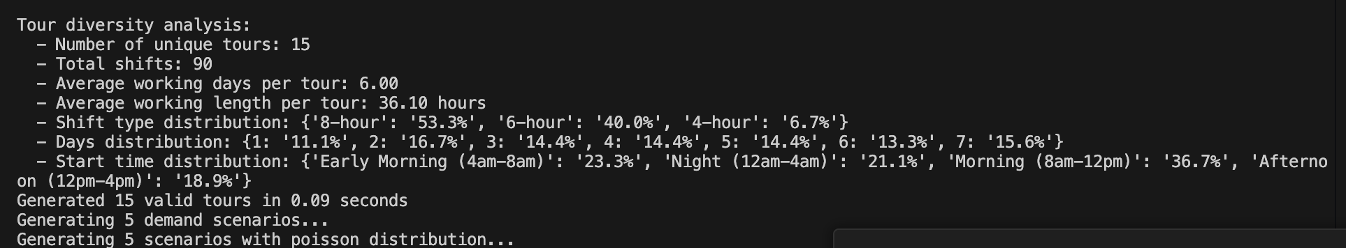
Figure 4: Analysis of the tours generated by the Pyomo-CBC solver.

SMASTP Metric | Baseline Value | Pyomo-CBC
VSS (%, higher is better) | 1.06% - 15.93% | 10.54%, 39.96%
Value in Time to Compute  (%, lower is better) | 135% - 175.6% | 313%, 336%
Time to Compute (Seconds) | 222 – 10,565.48 | 1.56, 1.47
Table 4: Values extracted from Restrepo, Gendron, and Rousseau table #3

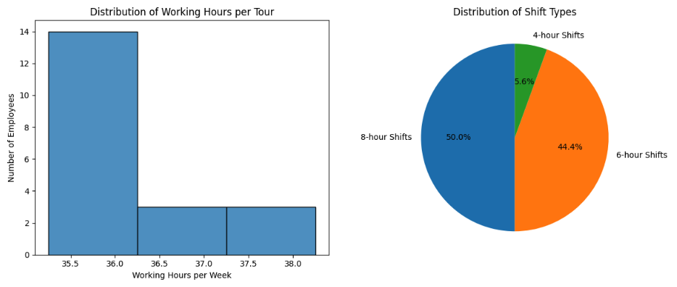
Figure 5: Charts Breaking Employee hours and Shift Distribution

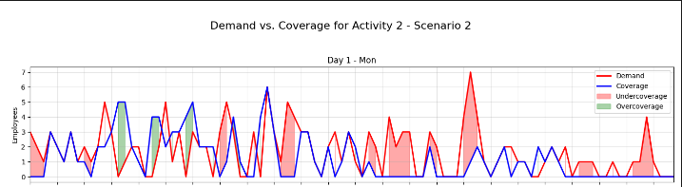
Figure 6: A scenario chart showing an insight into employee coverage

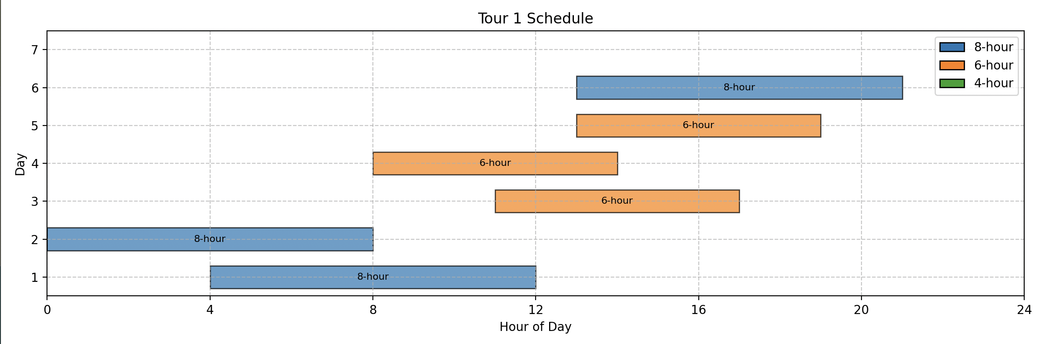
Figure 7: A chart showing an insight into one of the created tours.
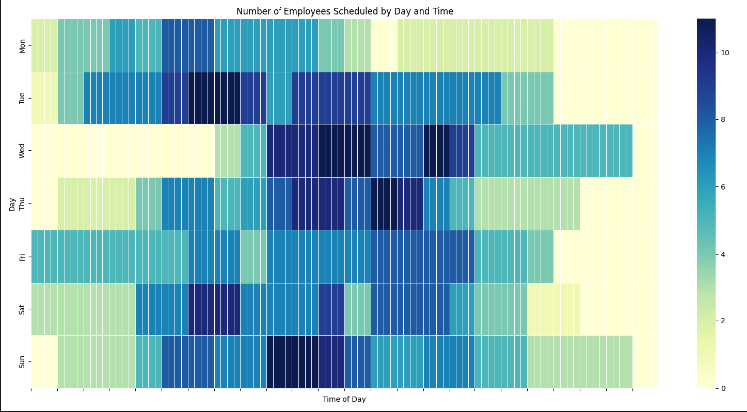 | 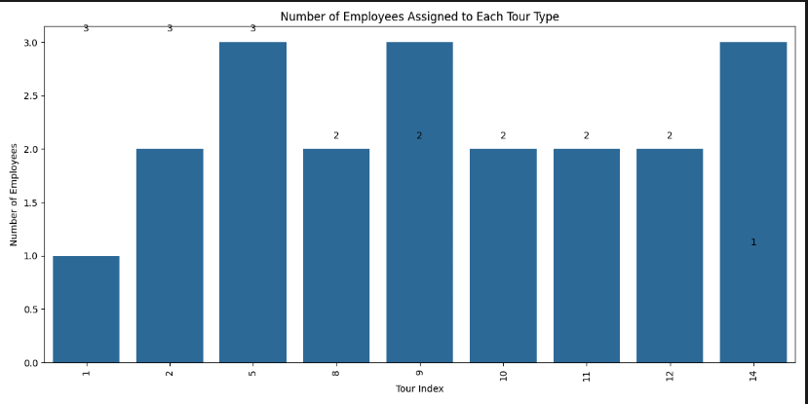
Figure 8: A Heatmap of when employees are scheduled (Left)
Figure 9: The assignment of employees to tours (Right)
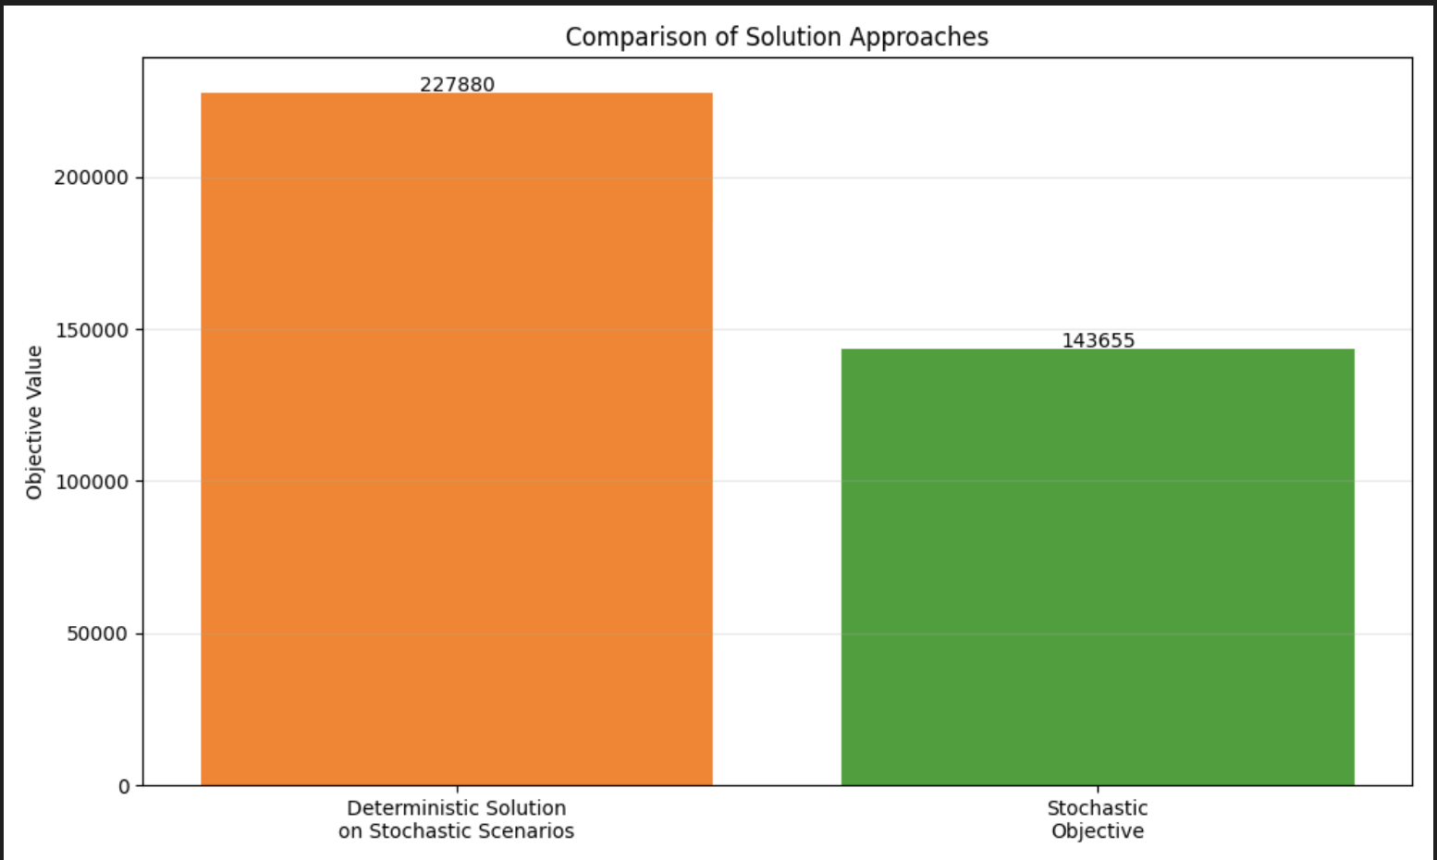
Figure 10: Deterministic Objective Value versus Stochastic Objective Value for the 20

Results Discussion

Objective Value Discussion
For this experimental part of this project the stochastic was arranged to have 5 scenarios across 7 days’ worth of 96, 15-minute activities. Each day was divided in such a way that assigned for 15-minute slot that a work activity with a demand of workers with an occasional break. The deterministic scenario was formulated to give enough workers to always meet demand per activity. By comparing the expected results of the deterministic scenario, if we were to always have enough employees on hand assigned to tours that meet demand the optimal cost would be $227,800 the stochastic scenario which followed our model got a value of $143,655. At first this seems positive, but at this stage the difference is hard to attribute without a more detailed breakdown of variable assignment. When the number of employees is increased to 40 with everything else remaining constant, the VSS drops from 36% to 10%, which reflects that the optimization approach has lost some of its advantage of efficient assignment. It is predictable that everything remaining constant while the cost of assigning employees doubled would reduce efficiencies.

Differences between Baseline Model outcomes and Experimental Outcomes
Although the visualizations of the current Tours, Demand versus Coverage, and overall schedule allocation show a lot of promise in following the original model there are some areas of concern. The computation time for example is wildly different. The solution for the Restrepo, Gendron, Rousseau approach was powered by an Intel Xeon X5675 processor, whereas the Pyomo-CBC solver was solved using an Apple M2 processor. Comparing the two processors shows that an Intel Xeon X5675 processer is 11 years older and only about 42% as powerful as the M2 [12]. It’s likely that the difference in speed only contributes a small difference. Additionally, the researchers’ models explored more potential scenarios and used the much more substantial CPLEX solver. It’s also likely that CPLEX Version 12.5.01 solver used is less efficient than the 2025-CBC solver. Overall although the visualizations demonstrate that feasible solutions are being reached in the Pyomo-CBC model, it must be considered if the CBC multi-cuts are being applied correctly. Due to the project’s complexity, there are webs of variables that have been assigned, rewritten, and assigned again, that therefore need thorough examination before the structure of the python code can be verified as a non-contributor to the project performance.

Next Steps for the Model
The next steps for this stage from these results are to further validate the model’s behavior and evaluate more scenarios to confirm that the current formulation can be applied to other scenarios. Currently, the number of tours, and tour visualization was a key place to start because there are just so many activities in a week, it will be straightforward to collect detailed information on actual employee arrangement. By reviewing more scenarios it’ll be clear if tweaking each parameter gives the expected impact. Once that is confirmed it’s possible to extend the model. As of now, the parameters associated with estimating demand are fixed. The parameters for cost are fixed. The parameters for length of shifts, types of activities, and number of employees are fixed. If the model is validated across multiple scenarios, it will be simple to layer on the natural language interface to the project. Overall, the results so far are very promising and it’s only a matter of testing and receiving feedback to tell if this approach is complete or needs to be tweaked.

Timeline (1/2 page)

The timeline consists of three stages. The first stage, “Initializing the Model”, involves selecting an existing stochastic solver to replicate, implementing the model using the Pyomo-CBC method, and validating its performance. This is where the project is at currently. Current, the project will remain in this stage for more time. The second stage, “Adding Natural Language”, focuses on transforming the model’s usability by ensuring it produces readable outputs and can process handleable inputs from users. This will allow the system to better interpret and respond to operational queries. he third and final stage, “Adding Complete User Experience”, involves integrating a user interface and a dashboard to improve accessibility and visualization. The final product will be capable of guiding users through structured queries and delivering optimized solutions in a clear and interactive manner. The entire project was planned for completion within three months, but the most ambitious features are going to be hard to reach. In the upcoming re-evaluation stage it’s likely the current attempt will be simplified, removing GDA and Tour optimization, and replacing them with some fixed schedules.
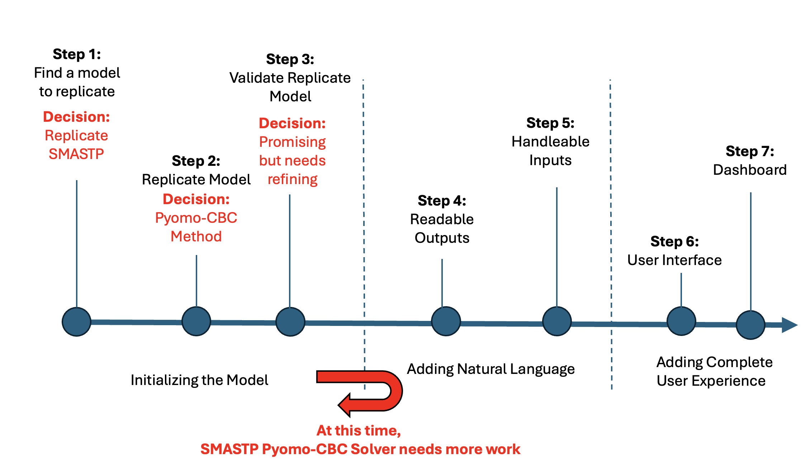
Figure 7: A visualization of a timetable with goals
References
[1] Hugging Face, "Models," Hugging Face. [Online]. Available: https://huggingface.co/models
[2] Pyomo Development Team, "Pyomo Documentation," Pyomo. [Online]. Available: https://www.pyomo.org
[3] GAMS Development Corporation, "GAMS Documentation," GAMS Documentation Center. [Online].
Available: https://www.gams.com/latest/docs/
[4] COIN-OR Foundation, "COIN-OR CBC (Coin-or branch and cut)," GitHub. [Online].
Available: https://github.com/coin-or/Cbc
[5] COIN-OR Foundation, "COIN-OR Interior Point Optimizer (Ipopt)," GitHub. [Online].
Available: https://github.com/coin-or/Ipopt
[6] IBM Corporation, "IBM ILOG CPLEX Optimizer Documentation," IBM Documentation. [Online].
Available: https://www.ibm.com/docs/en/icos/22.1.1?topic=optimizers-users-manual-cplex
[7] P. A. Meyer, "Stochastic Processes from 1950 to the Present," in Development of Mathematics 1950-2000, J. P.
Pier, Ed. Basel: Birkhäuser, 2000, pp. 813-848. http://emis.icm.edu.pl/journals/JEHPS/juin2009/Meyer.pdf
[8] Y. Yuan et al., "Multimodal data integration using deep learning predicts overall survival of patients with glioma,"
Preprint, 2024. [Online]. Available: https://doi.org/10.22541/au.171902942.22220133/v1
[9] J. J. Schneider and S. Kirkpatrick, "Stochastic Optimization," Berlin: Springer, 2006.
available https://link.springer.com/chapter/10.1007/978-3-540-34560-2_50
[10] E. A. F. Ekellem, "Operational Renaissance: Harnessing AI for Enhanced Business Efficacy," TH koeln, Dec.
2023. [online]. Available:
https://d197for5662m48.cloudfront.net/documents/publicationstatus/181021/preprint_pdf/a72514d62ea21d0fd5
041d9b295ec03c.pdf https://www.mdpi.com/1999-59
[11] M. I. Restrepo, B. Gendron, and L.-M. Rousseau, "A two-stage stochastic programming approach for multi-activity tour scheduling," European Journal of Operational Research, vol. 262, no. 2, pp. 620–635, Apr. 2017
[12] Technical City, "Apple M2 vs Xeon X5675," Technical City, 2025. [Online]. Available: https://technical.city/en/cpu/Apple-M2-vs-Xeon-X5675. [Accessed: 13-Mar-2025].

